UK Grade 1 – Pre-test
10 Questions | 30-45 minutes | Calculator not allowed
1.
Add.
a. 2 + 3 = ______ b. 7 + 3 = ______ c. 6 + 2 = ______ d. 5 + 5 = ______
Subtract.
a. 8 - 3 = ______ b. 5 - 3 = ______ c. 7 - 2 = ______ d. 10 - 5 = ______

2. Find the missing numbers.
a. 2 + _____ = 7
b._____ + 3 = 8

3. Put the numbers in order
a. 16, 61, 26 ______ < ______ < ______

b. 54, 14, 51 ______ < ______ < ______

4. Ten kids are playing in the yard. There are 6 boys. How many girls are there?

5. Andy had 20 dollars. He bought a book for 10 dollars and another for 5 dollars.
How much money does he have left?

6. A parking lot has spaces for 30 cars. There are cars in 22 of those spaces.
a. How many spaces are empty?
b. Two more cars arrive and park. Now how many cars are parked in the lot?
c. How many empty spaces are there now?

7. Write the time in two ways: using o'clock or half past, and with numbers.
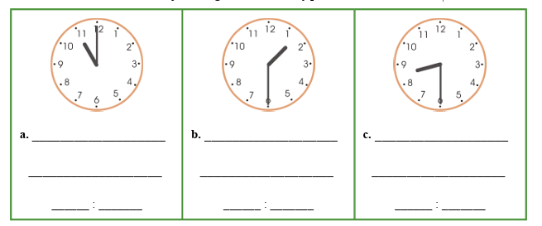
8. Draw a line that is:
a. 3 inches
b. 9 centimeters

9. a. Join these dots carefully with a ruler so that you get a shape.
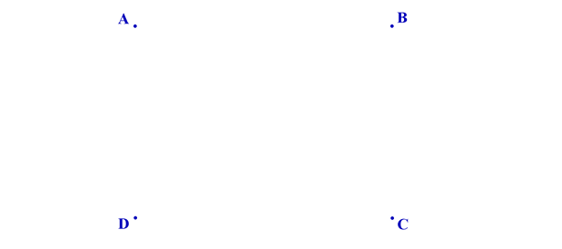
b. What is this shape called? ___________________________________________
c. Measure the sides of your shape in centimeters.
Side AB: ____________ cm Side BC: ___________ cm

10. Use the data to answer the questions.
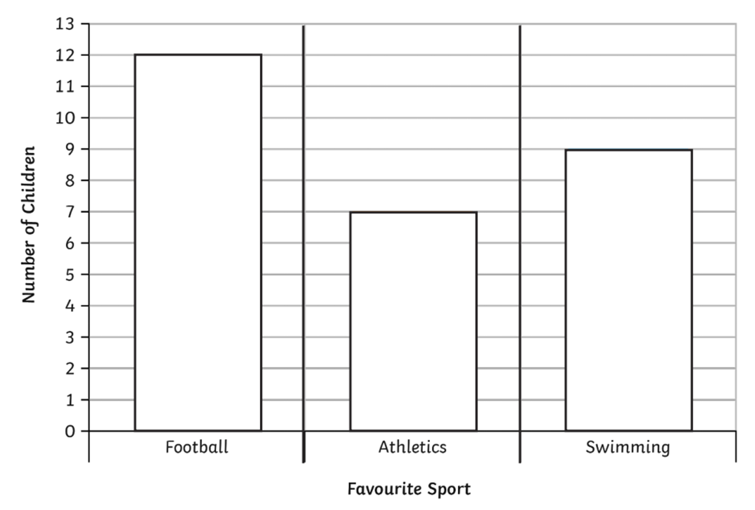
How many children preferred football? | ________________
How many more children like swimming more than athletics? | ________________
How many children voted? | ________________
Use the information below to answer questions 11-12.
The manager of a school cafeteria ordered some new kitchen supplies. He ordered 15 boxes of napkins, 3 boxes of paper cups, and 5 boxes each for plastic forks, knives, and spoons.
11. If there are 5 stacks of paper cups in each box, how many stacks of paper cups did he order?
____________________________________ stacks.
12. What fraction of the order is napkins?
____________________________________

